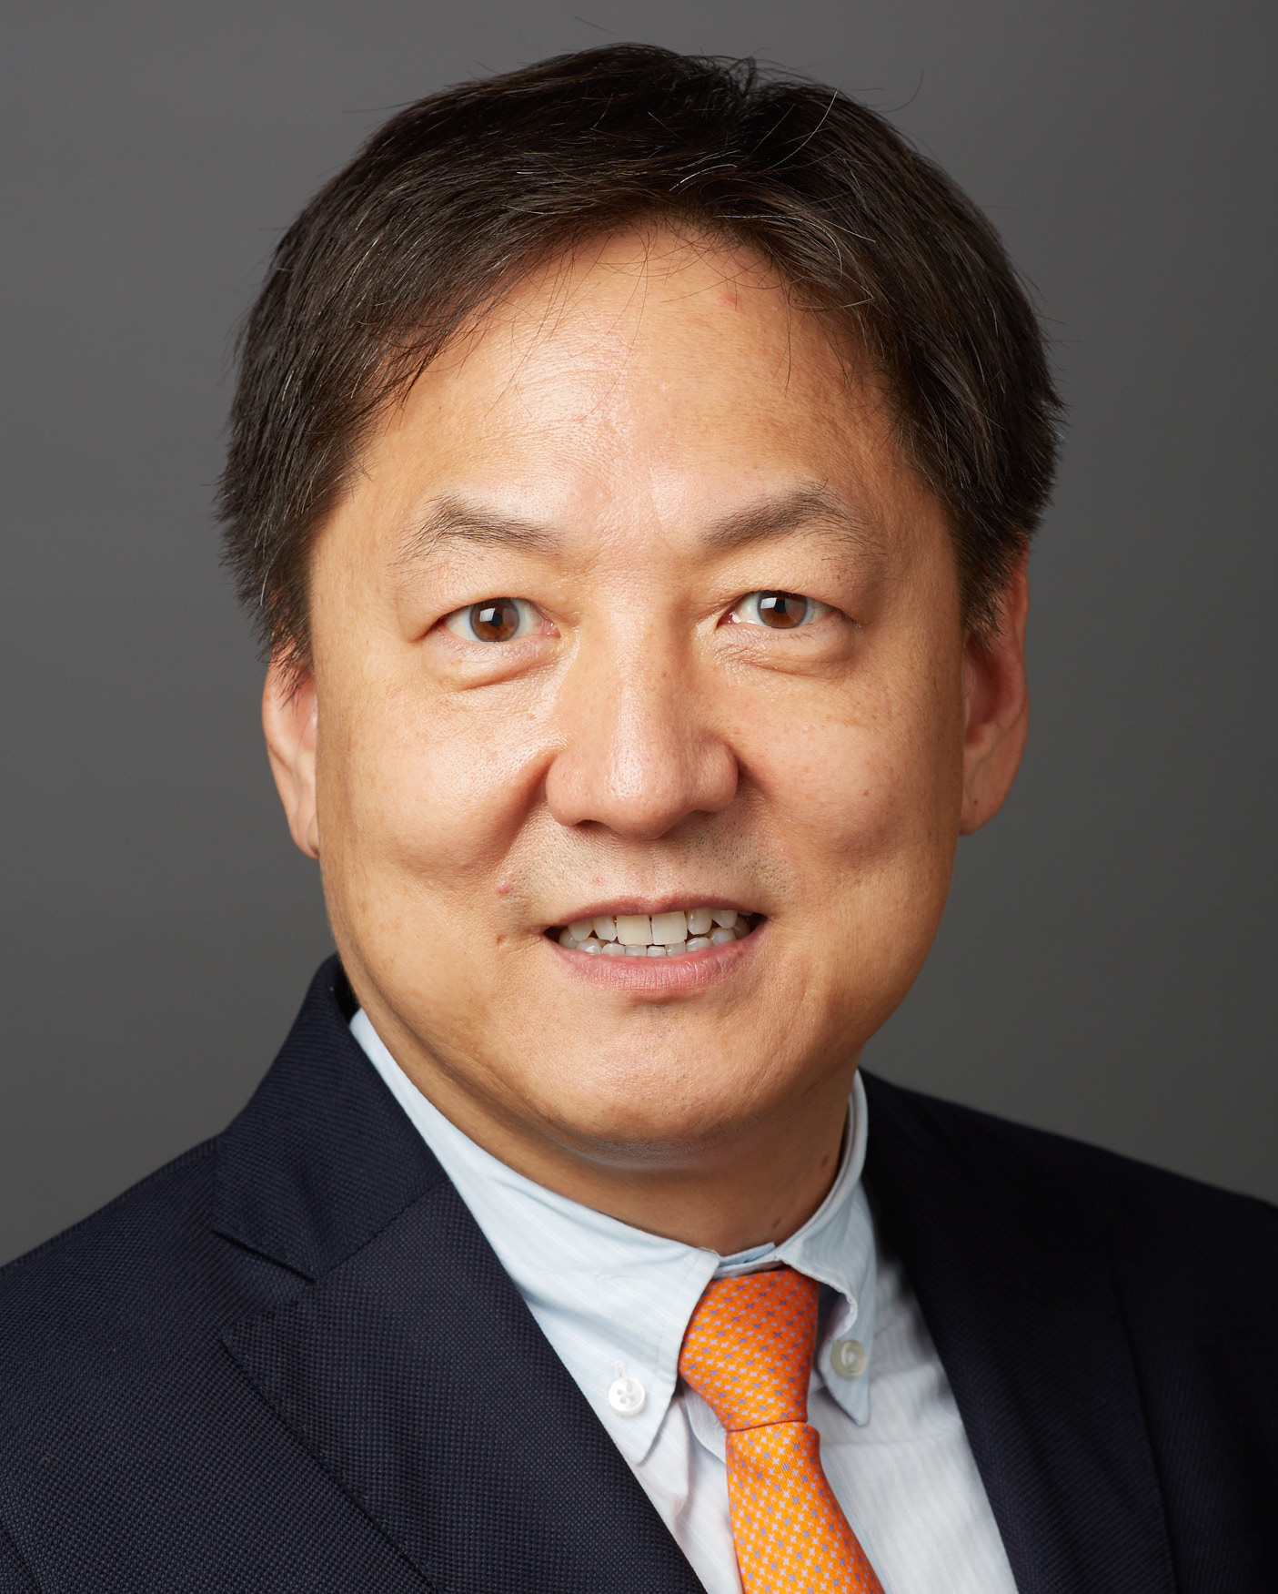
Francis Y. Lee, M.D., Ph.D.
Wayne O. Southwick Professor with Tenure
Department of Orthopaedics and Rehabilitation
Yale School of Medicine, New Haven, CT, U.S.A.

Dr. Lee a hybrid multi-faceted Orthopaedic Surgeon, NIH-funded Researcher, Educator, and Administrator. His activities at YSM, Center for Musculoskeletal Care, and YNHH will be typified as concurrent clinical/scholarly/educational time efforts, engaging students at the Yale University & School of Medicine, residents, fellows, PhD candidates, postdoctoral fellows, junior faculty members, visiting scholars, hospital staffs, and colleagues. Dr. Lee has developed diverse clinical, administrative, research, educational proficiency at the Columbia University, New York, NY for 17 years. He was a tenured Professor and Robert Carroll Professor at the Columbia University. He joined the Yale School of Medicine on September 1, 2016. In the Yale School of Medicine and Yale University, Dr. Lee an integral member of musculoskeletal researcher in the field of inflammation and tissue regeneration that plays a critical role in metastatic cancer, infection, implant loosening, and bone regeneration. Dr. Lee has been consistently funded by NIH R01 grants. He has served on numerous federal grant review panels and is Chair of NIH SBSR Study Section (2018-2020). Dr. Lee received Kappa Delta Award for his translational research on bone inflammation in 2016, which is a highest academic honor at the American Academy of Orthopaedic Surgeons. In the Yale New Haven Hospital System, Dr. Lee provides patient care in the field of musculoskeletal oncology, joint reconstruction & arthroplasties, infection, and pediatric orthopaedics at the YNNH, Cancer Center, Center for Musculoskeletal Care at Stamford, and Yale Greenwich Hospital.

